## Mengzhou Yao

## 08/04/2020

## IT FDN 110 A

## Assignment05

**To do List Script**

**Introduction**

In this assignment, I will add code to my “Assigment05_Starter”. The script will display a list of menu to the user: Show current data; Add a new item; Remove an existing item; Save Data to File; Exit Program.

**Procedure**

Script Title

Before creating the script, we must create script title as always.

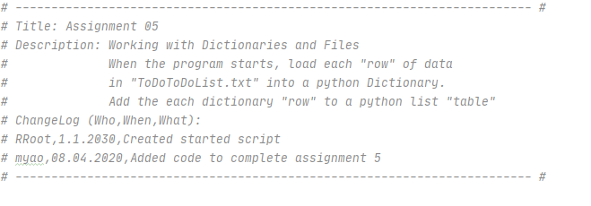*Figure 1: the screenshot of Script Title in the PyCharm program*

Creating Script

I The list of menu is already created in the script; I will load ToDoList.txt in the script by opening the txt file, listing the data as the dictionaries row, closing the txt file.

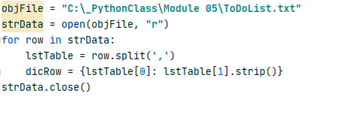

*Figure 2: the screenshot of the list of Menu in the PyCharm program*

The list of menu is already created in the script. If the user chooses ‘1’, the script will display the current data from txt file to the user by listing the data as the dictionaries row. The strip() will remove unwanted characters in the dictionaries rows.

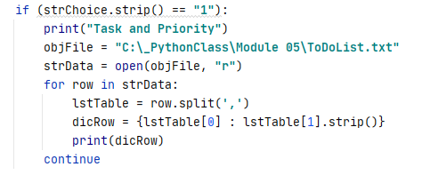

*Figure 3: the screenshot of the user choice is 1 in the PyCharm program*

.If the user chooses ‘2’, the user will enter the task and then enter its priority. The script will display those two piece of data as a dictionaries row.

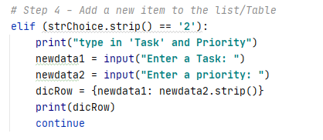

*Figure 4: the screenshot of the user choice is 2 in the PyCharm program*

If the user chooses ‘3’, the user will remove the one item from the list. The script will display the current data from txt file to the user by listing the data as one dictionaries row by including “***for row in strData”*** inside {}. If “***for row in strData****”* is coded in front of the disRow, we will have three dictionaries row. I use del dictionary[object] function to remove the item under “if…..else….” function. If item is in the list, it will be removed. If the item is not in the list, it will say “item doesn’t exist in the list”.

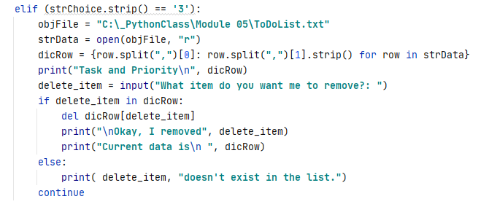

*Figure 5: the screenshot of the user choice is 3 in the PyCharm program*

If the user chooses ‘4’, the user will save two pieces of data in the ToDoList.txt. Those two pieces of data were entered by the user while the user chooses ‘2’. We will open the txt file, save to file, close the file.

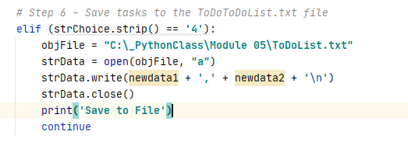

*Figure 6: the screenshot of the user choice is 4 in the PyCharm program*

If the user chooses ‘5’, the user will exit the program.

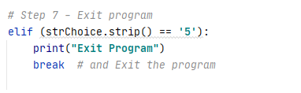

*Figure 7: the screenshot of the user choice is 5 in the PyCharm program*

Saving the script

I create a folder in C:\_PythonClass called “Assignment05” and save my script as “Assigment05”.

Running the script

I open PyCharm in search windows and open the “Assignment05” to run module, I choose “1” to display the current data. I choose “2” to enter “Write weekly plan” as the task, and enter “Low” as its priority. I choose “3” to remove “Empty email box” from the list. I choose “4” to save “Write weekly plan” and “Low” in the ToDoList.txt. I choose “5” to exit program.

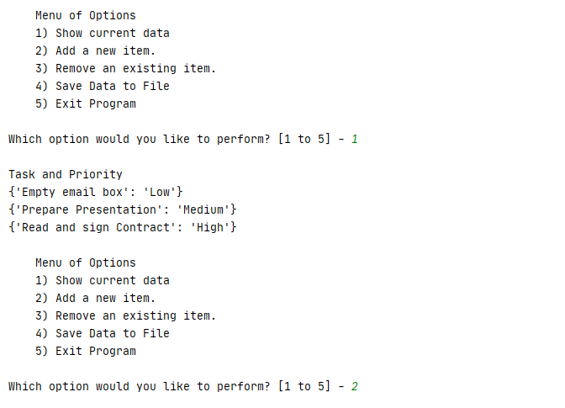

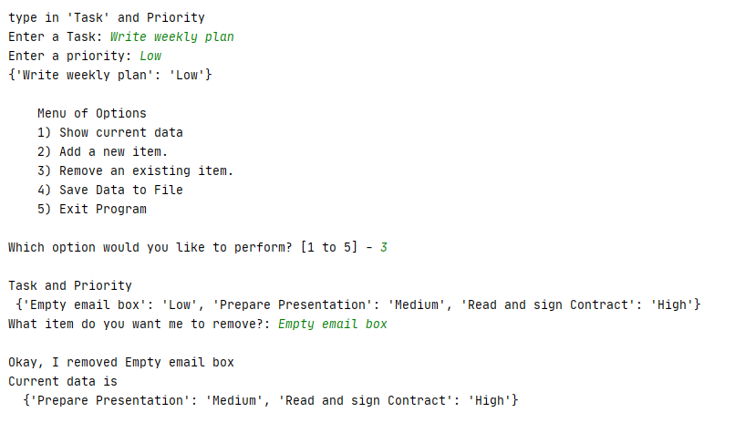

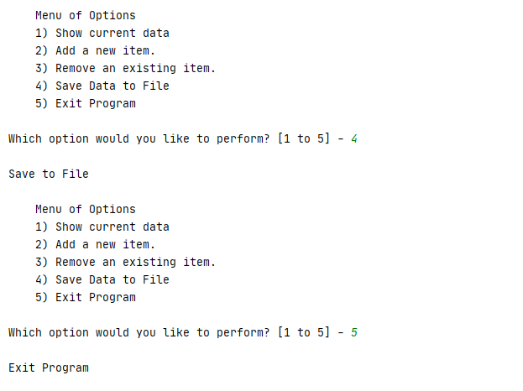

*Figure 8: the screenshot of running the script in the PyCharm program*

Verifying data in the txt.file

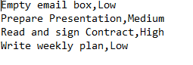

*Figure 9: the screenshot of verifying data in the txt file*

**Summary**

Using the module 05 video, notes, textbook, and supplemental video, I was able to add code in the to do list script by letting user to display the data, enter the data, remove the data, save the data and exit the program..